

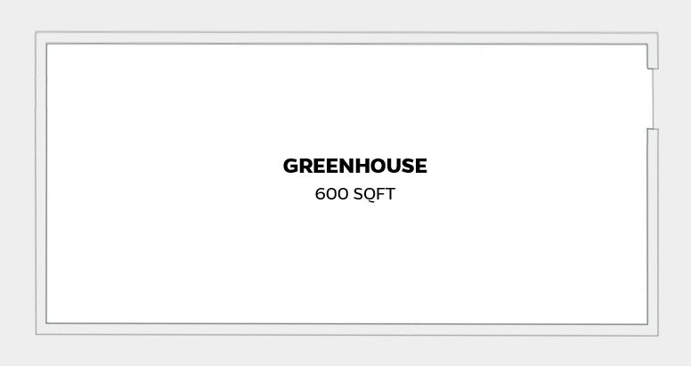

* Greenhouse with polycarbonate enclosure and ventilation fans
* Includes cinderblock and grate tables and built-in irrigation system.
* Total square footage: 600
* $1,600/month before tax with 2-year agreement ($32/sqft), or $1,700/month before tax with 1-year agreement ($34/sqft). Tax rate currently at 3.5% - subject to change annually.

**Client Amenities**

**Facility Access**

All-inclusive monthly membership fee for fully furnished offices and labs. No additional charge for parking, internet, utilities, trash valet, events, programs, or biological waste disposal. Official business mailing address included. Keycard card entrance for secure 24/7/365 access. Our facility has a backup power generator and is equipped with video security surveillance and monitoring. Access to the University of Florida wired network is available in all offices and labs, and Wi-Fi is available throughout the facility.

**Business Development Services**

* Business growth assistance and individual coaching wherever and however it is needed. Some companies come to us as startups; others as mature small businesses looking to grow. In any case, we work with you as requested, whether it be business or marketing planning, sales strategies, M&A, financing, or just plain contacts (“Do you know someone at…”).
* University of Florida discounted rates for access and use atthe Interdisciplinary Center for Biotechnology Research, the HiPerGator, and Animal Care Facilities.
* Publicity opportunities in the form of Press Releases, business articles, social media visibility, etc.
* Networking and collaboration opportunities with 90 + other startups in the program.
* Connectivity to “Preferred Service Providers” (lawyers, bankers, insurance agents, capital sources) to provide education and needed small business professional services.
* Community-building & educational events including CEO meetups, networking mixers, vendor shows, lunch & learns, and workshops.
* Access to proven business building programs and tools – pitching, de-risking, sales training, mentorship, lean startup tools, Amazon Web Services, SalesForce, GitHub, DropBox, online business planning support software, and more.
* Assistance sourcing internships, part-time, and full-time talent from the local community, University of Florida, and Santa Fe College.
* Opportunities throughout each semester to work with University of Florida master’s degree students for externships.
* Access to the University of Florida library system, both in person and online.

**Shared Services**

* On-site reception desk with visitor/guest help and management. Coffee bar.
* Business center with networked full-function color laser printer, fax, and scanner. Package management for Fed-Ex/UPS/USPS, and mailing/packaging supplies.
* The ability to choose from and reserve six conference rooms for your company discussions and private client meetings. Ability to reserve a seminar room for workshops, leadership training, and/or team meetings, with seating for as many as 20 people.
* Two common kitchen areas with refrigerator, microwave, vending machines.
* Bike racks, hydration stations, showers, dining options in breakroom, lobby and patio available for use.
* A seasoned team of business professionals available to help with needed resources, questions, issues, connections, coaching, etc. We are dedicated to the success of the company, founder, and team and work daily to provide a collaborative, supportive, and encouraging community for our entrepreneur’s flourish.